Literature Review

Paper 1:

[Artificial Intelligence Based Customer Churn Prediction Model for Business Markets - Faritha Banu - 2022 - Computational Intelligence and Neuroscience - Wiley Online Library](https://onlinelibrary.wiley.com/doi/full/10.1155/2022/1703696)

* Suggests using Artificial neural networks.
* Keywords used: CCP = Customer Churn Prediction
* “In an open-source Telecoms dataset, Halibas et al. [[18](https://onlinelibrary.wiley.com/doi/full/10.1155/2022/1703696#bib-0018)] performed exploratory data analytics and feature engineering, employing 7 classification methods such as Naïve Bayes(NB), Generalized Linear Model, LR, Deep Learning(DL), DT, RF and Gradient Boosted Tree(GBT)” – summary of another work
* 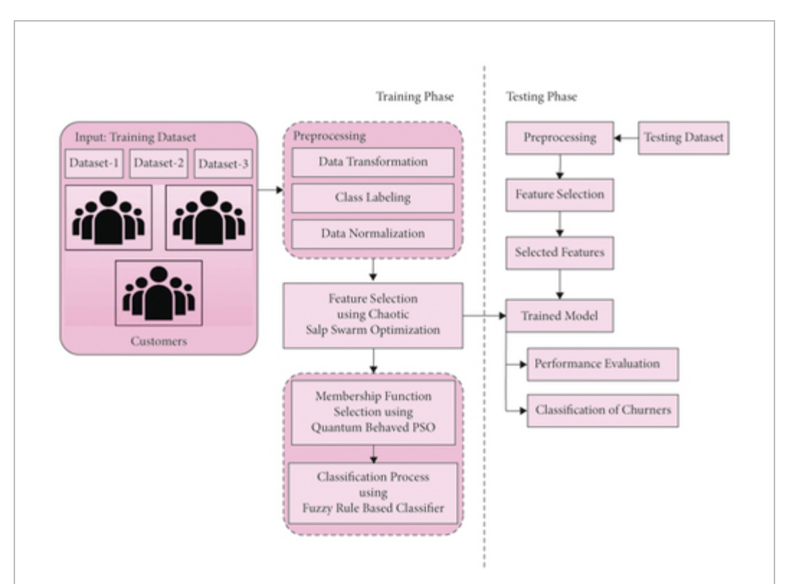
* Quantum Behaved Particle Swarm Optimization used to determine membership function in order to improve the classification performance of the Fuzzy rule based classifier.

Paper 2:

<https://al-kindipublisher.com/index.php/jcsts/article/view/7102>

* Used decision tree and random forest model.
* Seems to be done on the Telco Customer Churn dataset from Kaggle.
* Random Forest have higher accuracy of 96.25%.
* To use the model, they are asking to train the model again with the new data.
* Mentions User Interface but it has not been developed by them.

Paper 3 :

[View of AI-Driven Predictive Models Strategies to Reduce Customer Churn](https://injmr.com/index.php/fewfewf/article/view/52/16)

Suggests using AI but hasn’t actually done anything.

Paper 4:

[View of Utilizing Data Science and AI for Customer Churn Prediction in Marketing](https://centuryscipub.com/index.php/jtpes/article/view/593/504)

* Same Telecom customer churn dataset from Kaggle
* Variable selection + SMOTE for pre processing
* They used Random Forest, XGBoost and finally CatBoost (highest accuracy of 80.2%)

Paper 5:

[AI-Based Hotel Customer Churn Prediction Model | Journal of Progress in Engineering and Physical Science](https://www.pioneerpublisher.com/jpeps/article/view/1120)

* Again, only explores possibilities; doesn’t actually do it.